Batch-1

1)

Design a java program to handle the vip customer in bank. Design a class with a long variable called timer and a counter function to increment the timer. Design other threading class which is going to call the counter function. In the main function create three threads namely, VIP, Senior citizen and normal person. Initiate the threads and execute them. Assure that vip gets more time for service, means counter is executed more number of times for VIP thread.

2)

Design a java program for a vaccination camp center. The class can have various functions like getting personal details, time period, bill, and next dose date. In time period function check for the dates of first does and current date if its less than 25 days throw a TIMEINTERVALERR user-defined exception. If there is no exception generated print all personal details and bill details. If an exception is generated ensure to print the next dose date correctly. Calculate the next dose date exactly after 25 days of the first dose

3)

Three candidates Palaniswamy, paneerselvam and Stalin of Tamilnadu to contest for the Chief Minister election with the total strength of 240 MLAs. Write a Java program to simulate the vote casting by generating 240 random numbers (1 for OPS, 2 for EPS and 3 for Stalin) and store them in an array. Create four threads to equally share the task of counting the number of votes cast for all the three candidates. Use synchronized method or synchronized block to update the three count variables. The main thread should receive the final vote count for all three contestants and decide the Chief Minister based on the values received.

1)

Design a java program for a bike service centre. The class can have various functions like get personal details, warranty details, bill, and feedback. In warranty function check for the date of purchase and current date, if its more than one year throw an INVALIDWARRANTY user defined exception. If there is no exception generated print all personal details and bill details. If exception is generated ensure to print bill without warranty cost.

2)

Labour election candidates are Alex, sam and Sinha. The labour count is 1000. Write a Java program to simulate the vote casting by generating 1000 random numbers (21 for Alex, 31 for sam and 41 for sinha) and store them in an array. Create 2 threads to equally share the task of counting the number of votes cast for all the three candidates. Use synchronized method or synchronized block to update the three count variables. The main thread should receive the final vote count for all three contestants and decide the leader based on the values received.

3)

Design a java program for a bike service centre. The class can have various functions like get personal details, warranty details, bill, and feedback. In warranty function check for the date of purchase and current date, if its more than one year throw an INVALIDWARRANTY user defined exception. If there is no exception generated print all personal details and bill details. If exception is generated ensure to print bill without warranty cost

Batch-2

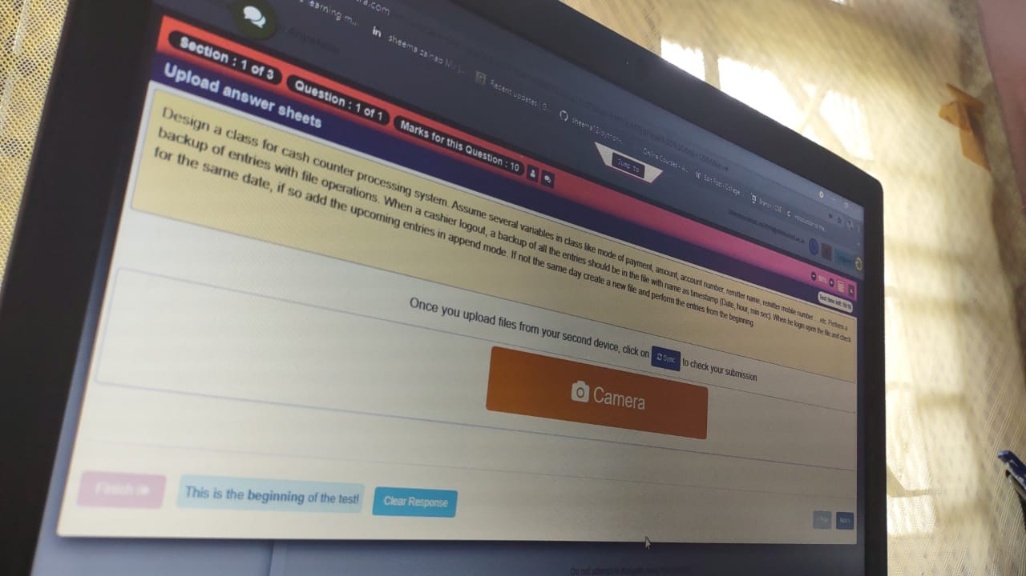

Design a class for covid vaccination information system. Assume several variables in class like age, amount, aadhaar number, name, mobile number…..etc. Perform a backup of entries with file operations. When a operator logout, a backup of all the entries should be in the file with name as timestamp (Date, hour, min sec). When he login open the file and check for the same date, if so add the upcoming entries in append mode. If not the same day create a new file and perform the entries from the beginning.

Design a class for share trading system. Create necessary supporting variables for a share trading system also which has share_value. The share_value is the variable used by many threads who has rights to update it from time to time. Imagine thread owner is modifying the share_value, other threads like, buyer1, buyer2, buyer3 has to wait till the owner notifies them. Also when share broker thread is modifying the share_value all others including owner has to wait till share broker notifies them. Use the multithreading concepts, wait, notify, notifyall, sleep, synchronized.

Design a class for gold trading system. Create necessary supporting variables for a gold pricing system also which has gold_value. The gold_value is the variable used by many threads who has rights to update it from time to time. Imagine thread owner is modifying the gold_value, other threads like, buyer1, buyer2, buyer3 has to wait till the owner notifies them. Also when IBJA ( Indian Bullion Jewellers Association) thread is modifying the gold_value all others including owner has to wait till IBJA thread notifies them. Use the multithreading concepts, wait, notify, notifyall, sleep, synchronized.

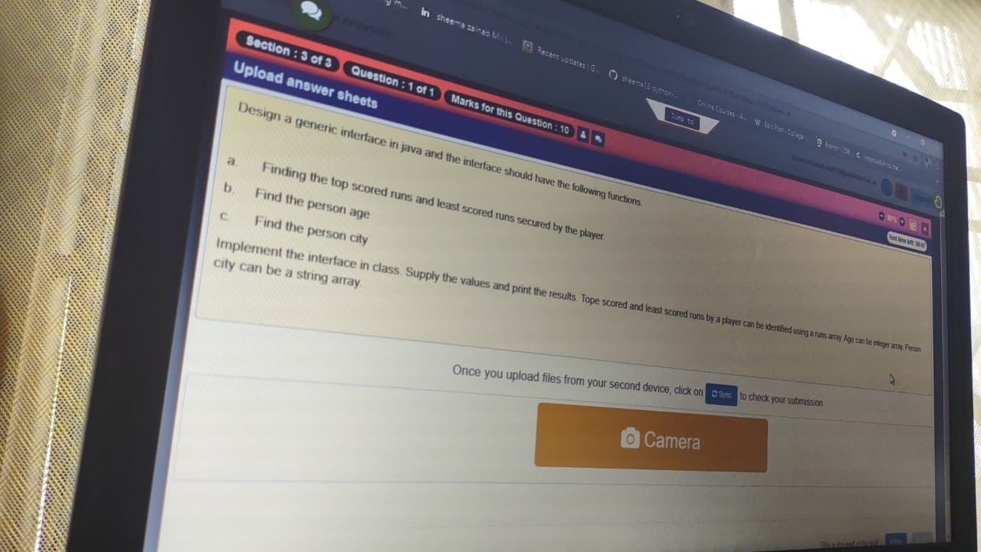

Design a generic interface in java and the interface should have the following functions.

a. Finding the top scored runs and least scored runs secured by the player.

b. Find the person age

c. Find the person city

Implement the interface in class. Supply the values and print the results. Tope scored and least scored runs by a player can be identified using a runs array. Age can be integer array. Person city can be a string array.

